SQL Server Instance Health Check Report
- Server Name: SERVERNAME
- Instance Name: SERVERNAME\ABC
Below are the list of Areas covered in this Health check.
Sr No | Evaluation Parameters
1 | Server and Instance information:
2 | Service Pack upgrade:
3 | High Availability Features:
4 | Services Running on the box:
5 | SQL Server Configuration: Parallelism
6 | SQL Server Configuration: Option (Optimize for ad hoc workloads)
7 | Database Backup Strategy:
8 | Backup compression default:
9 | Database Recovery Models:
10 | TEMPDB Configurations
11 | Database Growth Pattern:
12 | Database VLF Count:
13 | Database Option :: Page Verify
14 | Database Option :: Auto Create Statistics & Auto Update Statistics.
15 | Database Option :: IsAutoShrink.
16 | Database Option :: IsAutoClose.
17 | Database Integrity Check:
18 | Index Maintenance:
19 | Statistics Updation:
20 | Recycle error log:
21 | Trace Flag:

Server and Instance information:
-----------------------------------------------------------------------------------------------------

Microsoft SQL Server 2005 - 9.00.5000.00 (X64)
Dec 10 2010 10:38:40
Copyright (c) 1988-2005 Microsoft Corporation
Enterprise Edition (64-bit) on Windows NT 6.1 (Build 7601: Service Pack 1)
-----------------------------------------------------------------------------------------------------

- Machine Name: SERVERNAME
- Server Name : SERVERNAME
- Instance : TAX
- IsClustered : NO
- Edition : Enterprise Edition (64-bit)
- Product level : SQL Server 2005
- Product version : 9.00.5000.00
- Collation : SQL_Latin1_General_CP1_CI_AS

Recommendation:
As per Microsoft best practices, it is advisable to apply below

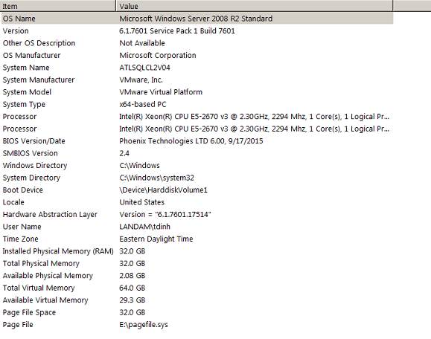

Run msinfo32

Service Pack upgrade:

The SQL server instance is always recommended to upgrade with latest patch release.
These patches have the bug fixes and security related code. These improves the performance and secure the database environment.

Before applying the patches on the production environment it is recommended to thoroughly test it on the test environment.

Edition | Version | Service pack | Recommendation
Microsoft SQL Server 2005 (SP1) | 9.00.5000.00 | SP1 | SP4

Latest SP
Latest CU
Latest Security Update

High Availability Features:
SQL Server high-availability solutions are implemented to improve the availability of servers or databases. A high-availability solution masks the effects of a hardware or software failure and maintains the availability of applications so that the perceived downtime for users is minimized.
High Availablity features like Clustering, Mirrioring, log shipping or Replicaiton should be enable for the production database. If helps during the Disaster recovery.

Evaluation:

This SQL instance is not part of High Availability.
Drive free space:
Below is the information about the Disk space consumption. All the drive have free space well above the 10% threshold.

Drive | Volume Name | Size  (in GB) | Free Size  (in GB) | Percentage  Free
C: |  | 149.9 | 92.55 | 61.7 %
E: |  | 70 | 37.9 | 54.4%
G: |  | 5 | 4.9 | 99%
O: |  | 299 | 286 | 95.6%
Z: |  | 299 | 293 | 97.6%

Services Running on the box:
Below is the screen shot of the Service running on the box.
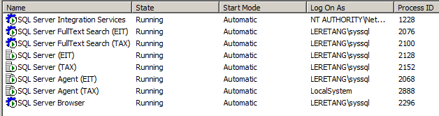

Evaluation of Services Account :
As the per the best practice the services such as Database engine and SQL server Agent should be configured to run under the Domain Account.
Recommendation :
SQL instance TAX Agent services running under local system. We suggest to run under Domain Account.

Evaluation of Service Account Startup:
As per the best partices, if the SQL server is not CLUSTERED then the services startype should be configured for AUTOMATIC.

Recommendation :
NONE, as the SQL Agent services Startup type is already set to AUTOMATIC.

Disabling the Unwanted Services:

For better utilization of memory. It is always recommend to Disable the services which are not in use.

Recommendation:
NONE.

SQL Server Memory Management:

SQL server Dynamicaly manages the memory utilization. Allocation and De-allocation of memory is managed by the SQL server. But it’s has tendencies to consume all the available memory. SQL server memory consumpation contributes of Internal Operation memory (BUFFER POOL) used by the Database object stored procedure and etc.
And on the external operation the process which runs outside the scope of the SQL server Memory (VAS).
Like CLR , linked servers etc.
Therefore, appropriately configuring the SQL server memory is very much important.
Allowing SQL Server to use memory dynamically is recommended; however you can set the memory options manually and restrict the amount of memory that SQL Server can access
With the option of min server memory and max server memory, to reconfigure the amount of memory (in megabytes) that is managed by the SQL Server Memory Manager for a SQL Server process used by an instance of SQL Server.
As best practices, 80% of Physical memory should be allocated among the SQL server instance internal operation BUFFER Pool.
And remaining memory should be free for Operating system and other operation which runs outside the scope of SQL Server (SSIS, CLR and etc)
Machine Name | Physical memory | Instance Name
SERVERNAME | 32 (GB) | TAX

Current Configuration |  | DV_Recommendations
Min Server Memory | Max Server Memory | Min Server Memory | Max Server Memory
0 | 6700 | Looks OK | 13312 MB/ 16384 MB per default instance

SQL Server Configuration: Parallelism

Below are the configuration setting which controls the parallelism:

Cost Threshold of Parallelism:

SQL Server creates and runs a parallel plan for a query only when the estimated cost to run a serial plan for the same query is higher than the value set in cost threshold for parallelism. The cost refers to an estimated elapsed time in seconds required to run the serial plan on a specific hardware configuration

Max Degree of parallelism:
When SQL Server runs on a computer with more than one microprocessor or CPU, it detects the best degree of parallelism, that is, the number of processors employed to run a single statement, for each parallel plan execution. You can use the max degree of parallelism option to limit the number of processors to use in parallel plan execution. To enable the server to determine the maximum degree of parallelism, set this option to 0, the default value. Setting maximum degree of parallelism to 0 allows SQL Server to use all the available processors up to 64 processors. To suppress parallel plan generation, set max degree of parallelism to 1. Set the value to a number greater than 1 to restrict the maximum number of processors used by a single query execution.
Use the following guidelines when you configure the MAXDOP value.
Less than 8 logical processors | Keep MAXDOP at or below # of logical processors
Greater than 8 logical processors | Keep MAXDOP at 8
Less than 8 logical processors per NUMA node | Keep MAXDOP at or below # of logical processors per NUMA node
Greater than 8 logical processors per NUMA node | Keep MAXDOP at 8

If the parallelism is hurting the query performance; we would recommend increasing the cost of threshold of parallelism value.

Machine Name | Max Degree of Parallelism | Cost of threshold of parallelism | Logical processor | DV Recommendation
SERVERNAME | 0 | 5 | 2 | 2

SQL Server Configuration: Option (Optimize for ad hoc workloads)

The “optimize for ad hoc workloads” option is used to improve the efficiency of the plan cache for workloads that contain many single use ad hoc batches. When this option is set to 1, the Database Engine stores a small compiled plan stub in the plan cache when a batch is compiled for the first time, instead of the full compiled plan. This helps to relieve memory pressure by not allowing the plan cache to become filled with compiled plans that are not reused.
Evaluation:
SQL server 2005.

Recommendation:
Nil.

Database Backup Strategy:

Backtype | Job name | Database | Schedule | location | Retention
Full | Full DB Bkup Plan.  Subplan_1 | All Databases | Every 24 hours | O:\MSSQL\Backup\TAX | 3 days

Recommendation:

- No Recommendations.

Central Backup repository for offsite backup:
- We also recommend to move the backup on the network location and from there move it to offsite location.

Database Recovery Models:
SQL Server backup and restore operations occur within the context of the recovery model of the database. Recovery models are designed to control transaction log maintenance. A recovery model is a database property that controls how transactions are logged, whether the transaction log requires (and allows) backing up, and what kinds of restore operations are available. Three recovery models exist: simple, full, and bulk-logged. Typically, a database uses the full recovery model or simple recovery model. A database can be switched to another recovery model at any time.

FULL Recovery model: Can recover a database to a specific point in time if it is crashed or
Unavailable (assuming that your backups are complete up to that point in time)

SIMPLE Recovery model: Can recover only to the end of a backup.

Evaluation:
All user databases are in Full Recovery Model.

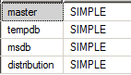

Recommendation:
Note: Recovery Model: Recovery models are designed to control transaction log maintenance and for recovering the database. Hence, recommended to change database recovery model to FULL.

Database Compatibility
One databases are with Compatibility as 90 as per SQL server 2005 enterprise edition.

SQL jobs with non SA owner.
Below jobs has got Non SA as owner.
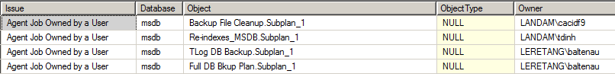

Recommendations:

Recommended to change job owner to SA

Database Collation:
All the databases has got same collation setting as that of the server. No Recommendations.

TEMPDB Configurations
Tempdb is heavily used system database. SQL server database engine uses it like a scratch pad.
In every operation of SQL server tempdb is used. Therefore for optimal performance tempdb should be configured.
As a general rule, if the number of logical processors is less than 8, use the same number of data files as logical processors. If the number of logical processors is greater than 8, use 8 data files and then if contention continues, increase the number of data files by multiples of 4 (up to the number of logical processors) until the contention is reduced to acceptable levels or make changes to the workload/code.

Evaluation:
This server has 2 logical processor. Below is the screen shot for the same.

Below is the details of current tempdb files
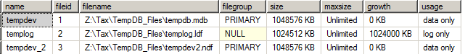

Recommendation:

No Recommendation
Database Growth Pattern:

Database growth settings is set to default. We have noticed that most of databases file growth is set correctly but few of them is set in percent which is not recommended, We will recommend to set them in MBs.
We have attached the details of file with Auto growth in percent.

Database VLF Count:
We should not have large number of VLFs as it can lengthen recovery time and can negatively affect performance of your database. High VLF count can increase IO requests and affects the performance.

Recommendation:
If auto-growth is enabled, the increments should be in appropriate MBs, not percentage. In addition, the growth increment should be sized appropriately.

Database Option: Page Verify
The PAGE_VERIFY option discovers database pages which have been damaged by disk errors; normally caused by hardware failure or power outage.
If SQL Server finds a page which it suspects is damaged, error number 824 will be raised. Depending on the value of the PAGE_VERIFY setting, the message will report the type of suspected condition (torn page or checksum error). Normally such errors are raised during database recovery at SQL Server startup.
SQL Server will write the error to its error log as well as to the application event log and retry reading the damaged page up to four times. If any of these attempts are successful the read operation will move on to the next data page, otherwise the read operation will fail.
Any time error 824 is raised, SQL Server will write a record to suspect pages system table in msdb database, however, the pages might still be readable even if they're suspected. If the read operation does fail, you'll have to attempt fixing the database using the DBCC CHECKDB statement. If only index pages are damaged, you can usually resolve the problem by rebuilding the index.

CHECKSUM: This option advises SQL Server to calculate a checksum over the contents of each data / index page when it is written to disk. This value is stored in the page header. When the page is read from the disk, checksum is computed again and compared to the value in page header.
The TORN_PAGE_DETECTION value configures SQL Server to save a specific bit for each 512 byte sector on the data / index page. This allows SQL Server to detect I/O operations that might have been interrupted due to power failures or other types of system outages. If the saved bit is in a wrong state when the page is read from disk, the error 824 will be raised indicating a torn page.
Evaluation:

All databases has CHECKSUM enabled.

Recommendation

No Recommendation

Database Option :: Auto Create Statistics & Auto Update Statistics.
The statistics is referenced by the indexes/Queries for fast retrieval of the records. For optimal generation reference of execution plan statistics on table/indexes should be up-to-date.
If this option is enable, the sql server automatically creates the missing statistics and updates any outdated statistics.

Evaluation :

We noticed on all the database both this option is enabled.

Recommendation :
NONE

Database Option :: IsAutoShrink.
If this option is enabled, To reclaim the free space the SQL server will automatically shrink it and that can adversely affect the performance of the database.
And it is always advisable to shrink the database during off peak hour under the DBA guidance’s.

Evaluation :
We have verified on all the database this option is disabled.

Recommendation:
NONE

Database Option :: IsAutoClose.
SQL Server is one of the easiest databases to maintain because of all of the automatic settings it has, but as I mentioned with Auto-Close, some of them should be left off. The Auto-Shrink setting is one of the feature that might surprise a few people.
You might think from the name of this operation, that you would want your databases to automatically reclaim any space they take whenever they can. And if SQL Server will handle that for you, all the more wonderful. But in fact, shrinking a database can cause your Indexes to be fragmented, especially if it happens a lot. I never shrink my databases unless I have a huge deletion of data, and I know that the data won't come back. That's a pretty rare event, and when it does happen I run the shrink operation manually and rebuild my indexes after.

Evaluation :

We noticed on all the database this option is disabled.

Recommendation :
NONE
Database Integrity Check:
DBCC CHECKDB checks the logical and physical integrity of all the objects in the specified database.

Evaluation :
We have verified the server and found out that there is NO Database Integrity Job on the server.

Recommendation :
We recommend to create Database Integrity Job.

Index Maintenance:
Due to DML operation the indexes gets fragmented And for the optimal performance of the database the indexes needs to be defrag regularly.

Evaluation :
We have verified Index maintenance job exists on the instance.

Recommendation :
None

Missing Index list: Attached Excel provides the list of missing indexes. Creating these missing indexes will help improve the seek/scan operation of the predicates in the query. This will in turn help the overall performance of the query. Evaluate these indexes for a potential benefit to the queries.
Note: Attached missing indexes

Unused Index List: Attached Excel provides unused index list. These indexes should be evaluated and can be dropped if they are not being used by any queries. This will eliminate the unnecessary I/Os on the server.
Note: Didn’t find any unused indexes
Duplicate Index List: : Attached Excel provides list of duplicate indexes. We have checked these index columns they already have indexes on these columns. These duplicate indexes can be safely dropped to avoid I/Os on the server.

Statistics Update:
Updates query optimization statistics on a table or indexed view. By default, the query optimizer already updates statistics as necessary to improve the query plan;
This helps us the database engine optimizer to select the optimal query plan which boots the SQL server performance.

Evaluation :
We have verified there is no update stats job present on server so need to create update statistics job.

Recommendation :

Recommend to create update statistics job.

Recycle error log:
The SQL server error log gets recycled when SQL server is restarted. If the SQL server is not been restarted for long time the error log grows bigger and that cause problem while opening. Therefore implementing the Weekly recycle error log job’s maintains the SQL log size restricted.

Evaluation :
We have verified there are no Recycle error log available on the instance.

Recommendation :

We would recommend to create a job for the same.

Trace Flag:
The enabling the Deadlock trace flag. This helps to capture the dead lock information in the error log.
- Trace Flag 1204: For deadlock detection, logging
- Trace Flag 1222: Returns the resources and types of locks that are participating in a deadlock and also the current command affected, in an XML format that does not comply with any XSD schema
- Trace Flag 1204: For deadlock detection, logging
- Trace Flag 1222: Returns the resources and types of locks that are participating in a deadlock and also the current command affected, in an XML format that does not comply with any XSD schema
- Trace Flag 3605: Output DBCC Commands to the SQL Error Log (undocumented Trace Flag)

Evaluation :
There in no Trace flag enabled on server.
Recommendation:
We recommend to enable the above mentioned trace flag.

Consolidated Recommendation:

- Please upgrade to Latest Service pack (SP4) of SQL Server.
- Create CheckDB job and Update statistics job.
- Enable Mentioned trace flag

